

**(UGC Autonomous)**

##### RURAL IMMERSION PROGRAMME

##### Report on the Field Work Conducted as a Part of Curriculum

# In the II Semester of Master of Business Administration

***By***

**1. P. BHARGAVI (Reg. No. 22691E0026)**

**2. E. MANIKYA (Reg. No.22691E0093)**

**3. M. MANJULA (Reg. No.22691E0094)**

**4. T.SASI KIRAN REDDY (Reg.No.22691E00F8)**

#### Under the Guidance of

#### Dr. N. GANGI SETTY

#### Professor



**DEPARTMENT OF MANAGEMENT STUDIES**

**MADANAPALLE INSTITUTE OF TECHNOLOGY & SCIENCE**

(UGC Autonomous - Affiliated To Jawaharlal Nehru Technological University-Anantapuramu)

MADANAPALLE- 517 325

ANNAMAYYA DISTRICT, A.P.

**2022-2024**



**(UGC Autonomous)**

**Department of Management studies**

***CERTIFICATE***

*This is to certify that this report on Rural Immersion Program me is a bonafide record of practical work done by MS. P.BHARGAVI* (22691E0026), Mr.E.MANIKYA (22691E0093), Ms. M.MANJULA (22691E0094,), Mr .T.SASI KIRAN REDDY *(22691E00F8) Of MBA programme in the II Semester during the academic year 2022-2023*

**Signature of the Guide Head of the Department**

#### Dr. N.GANGI SETTY Prof Sremmant Basu

#### Professor Ph.D--IIT Kharagpur

Rural Immersion Guide Dean –Administration & International Relations

Head-department of Management Studies

**Signature of the Examiner**

DECLARATION

We declare that this report on the Rural Immersion Programme is a bonafide work done under the guidance of **DR.N. GANGI SETTY Professor**, Department of Management Studies, **Madanapalle Institute of Technology & Science**, Madanapalle, as a part of MBA Curriculum. It is a record of original work done by us in KANDUR (Village name).

**1. P. BHARGAVI (Reg. No. 22691E0026)**

**2. E. MANIKYA (Reg. No.22691E0093)**

**3. M. MANJULA (Reg. No.22691E0094)**

**4. T. SASI KIRAN REDDY (Reg. No.21691E00J5)**

**Date:**

**Place:**

|  |  |  |  |
| --- | --- | --- | --- |
|  | | | |
| **INDEX** | | |
| **S. No** | **Contents** | **Page No** |
| 1 | Village Profile: Population, Literacy rate, No. of households, Occupation | 1-3 |
| 2 | Historical Background | 3 |
| 3 | Cultural Aspects | 3-4 |
| 4 | Agriculture | 5-6 |
| 5 | Economic Conditions of the people, consumption & Production | 6-7 |
| 6 | Education | 7-12 |
| 7 | Nutrition, Health and Wellbeing | 12-13 |
| 8 | Water resources and Sanitation | 13 |
| 9 | Skill Development and Job creation | 13 |
| 10 | Sustainability and climate action | 14 |
| 11 | Electricity and Clean Energy | 14 |
| 12 | Family Income | 14-15 |
| 13 | Infrastructure (Roads, water tanks, pumps, communication facilities, bridges, storage facilities, small scale industries, irrigation facilities etc) | 15-17 |
| 14 | Implementation of Govt. Schemes | 17-21 |
| 15 | Any other relevant issue for discussion | 21 |
| 16 | Suggestions Offered | 22 |
| 17 | Conclusion | 23 |

**RURAL IMMERSION PROGRAM**

**KANDUR VILLAGE**

**INTRODUCTION**

Rural growth in India has developed rapidly in now a days. And also government also spending more money for developing for rural area .and try to change the modern rural India. rural immersion program helps to study to understand rural situation and with field work for two days. This initiative field work is very experienced to my team. And also my team is also absorbing what kind of developments are there in the rural area and also what kind of developments are there, and what kind of facilities are really want to villages in now a days. And understand the behavior of the people in field working knowledge

|  |  |
| --- | --- |
|  |  |

**RURAL** ;-

 Rural areas consist of open countryside with population densities less than 500 people per square mile and places with fewer than 2,500 people

**IMMERSION ;-**

Immersion is the act of submerging something with in the area with images, videos, questioner type based submergin.

**VILLAGE PROFILE:**

|  |
| --- |
|  |

In this village can have a association of buildings and with government certain facilities like education, health care, small scale industries……etc. and it a smaller than a town .

**TOTAL POPULATIONS OF THE VILLAGE: -**

|  |  |
| --- | --- |
|  | **5376** |
| male | 2715 |
| Female | 2661 |
|  |  |

* According to the public health commission and grama sachivalayam and survey in village total**5376** population is there in this village
* In this village total **1751** houses are there
* In this village 30% of the peoples are depending on cattle, and 40%of the peoples are depending on the agriculture, 20% are depending on daily wages (agricultural Labor’s, buildings labors), remaining 10% are self Employed peoples.

**2.HiSTORICAL BACKGROUND; -**

Kandur was announces Grama panchayat in the year of 1912. And also Gram panchayat recently grandly celebrated the centenary in 2012 .and this village can celebrates the lot of historical festivals like Sreerama navami, sankranthi, Christmas festivals in every year

**3.CULTURAL ASPECTS:**

There is a historical temple in this village. Their name as the sreerama temple .this temple was build many years ago But when the temple got old their temple was demolished and rebuilt 2 years ago. This is one of the historic temple in this village. and also ( HINDUS ,MUSALMAN, CHRISTIANS ) all types of temples are available in this village

|  |
| --- |
|  |

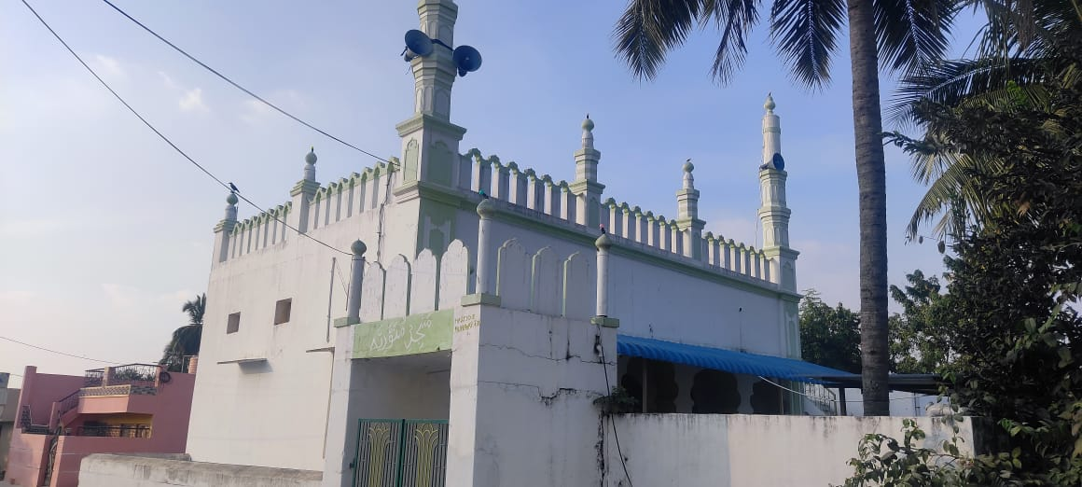

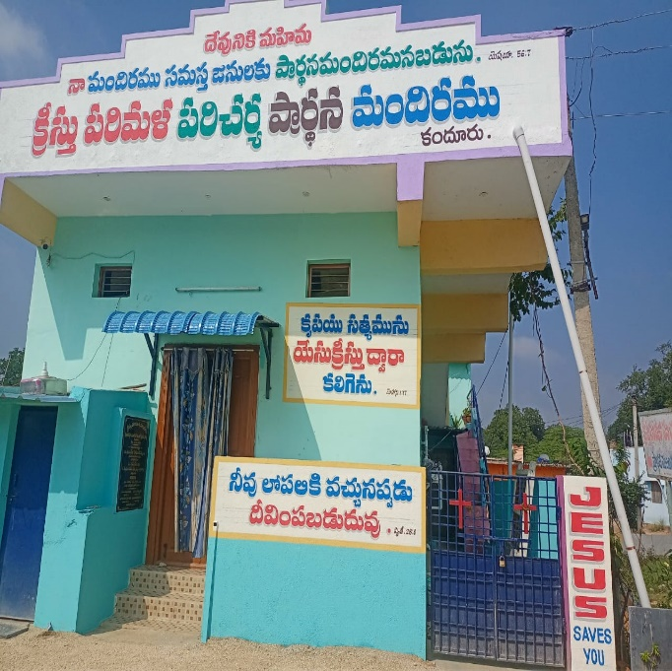

**4.AGRICULTURE ;-**

whole village is agricultural land. Majority of production Tomato crops, rice crops, minor crops are corn crops and ground nuts crops. And in this village 4 families are doing the betel leaf garden in this village these are the major and minor crops in this village

BETAL LEAFS:

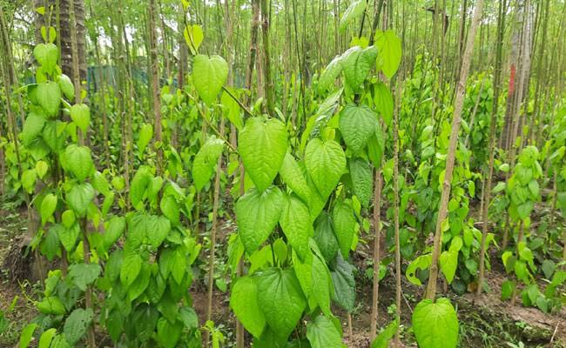

**Tomato:**

This panchayat has a large production of tomatoes among the surroundings of all panchayaths is especially plays a special place for the tomatos. The farmer would place the seeds of tomatoes and after 2 months they will get the crop of tomatoes and they will export to cities and sold to markets . By exporting they will get minimum profits instead of selling to markets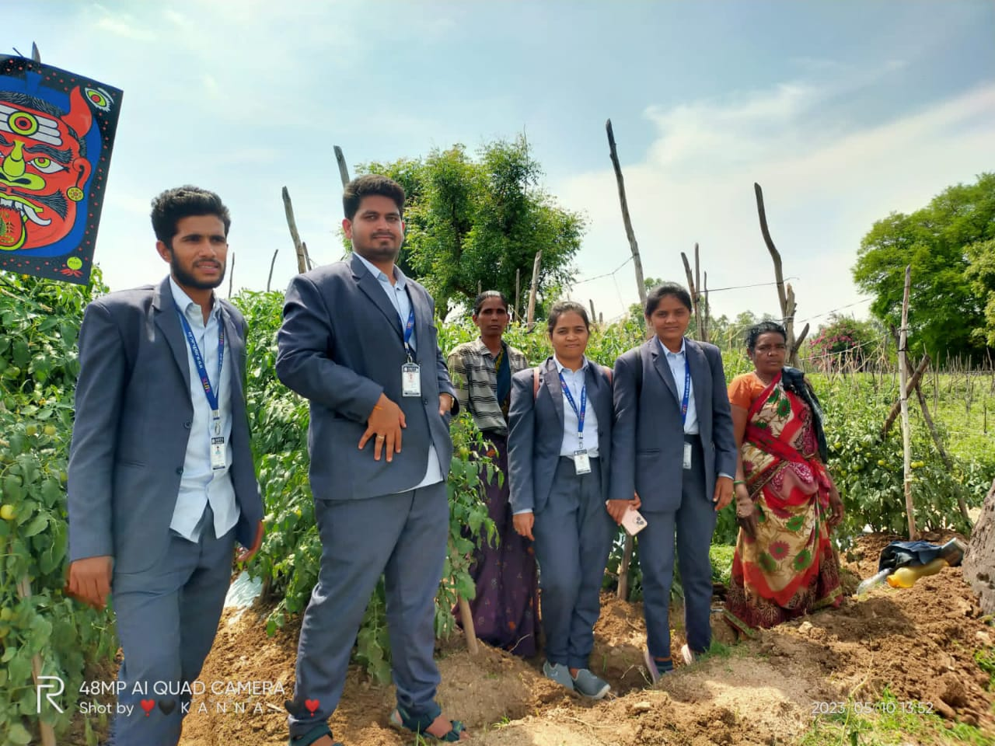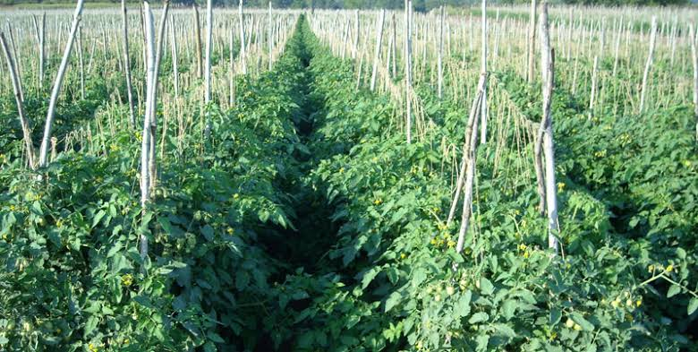

5.**Economic conditions of the people, Consumption & Production**

The Economic Conditions of the people are well and good. Almost every villager has been living in a very good condition as we observe. They grow paddy for their own consumption. Economically village was grow last few years because of the education and government support and economically support. These are reasons are to grow economically

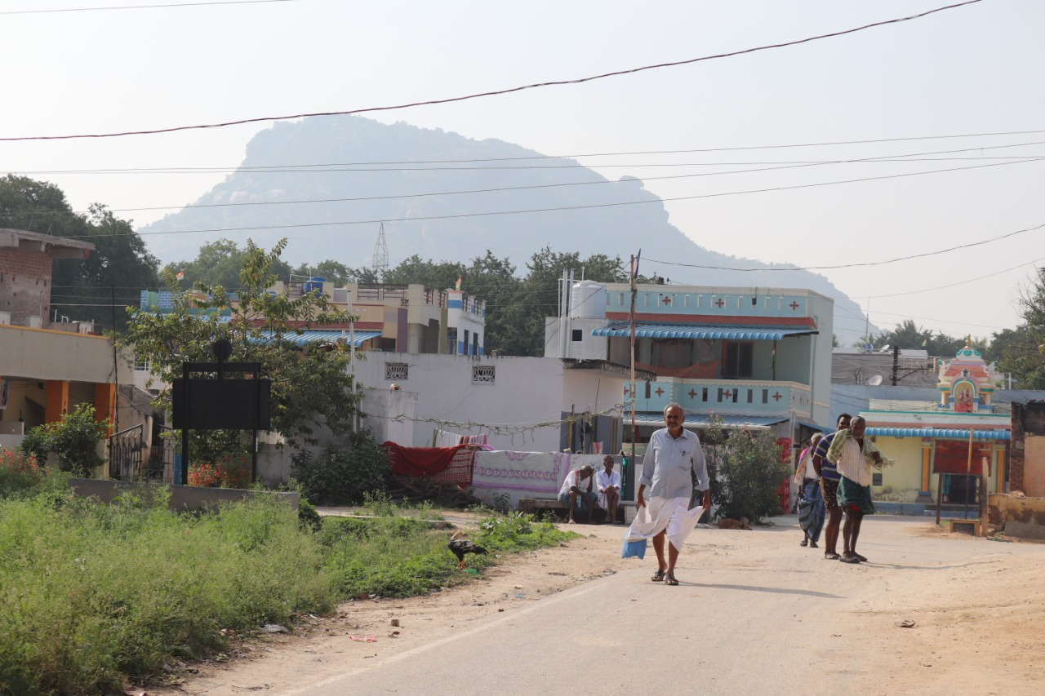

**6.EDUCATION:**

HIGH SCHOOL:

* ZPGH high school was Established in the year of 1959
* In this school total 17 members of teachers and 1 nonteaching staff are available and also PT teacher are not available in the school Total 368 member of students are there in thi

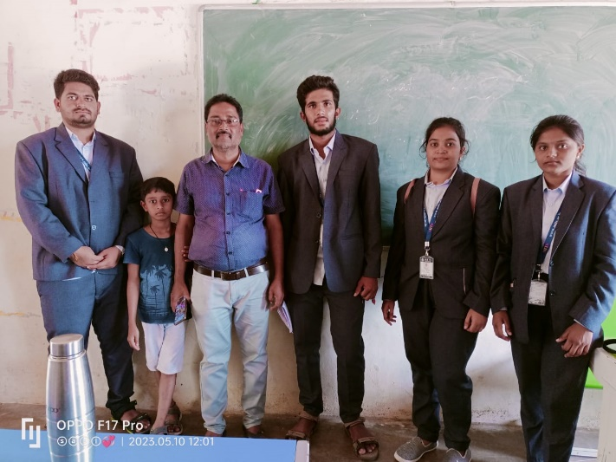

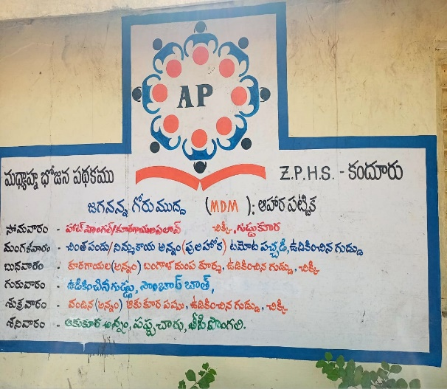

|  |
| --- |
|  |

* Drinking water (RO) facility and toilet facilities are well in this school
* Rooms deficiency is there in this school and recently under nadunedu program school rooms are under constriction
* Compared to last year students (418) strength 50 students admissions are decreased due to private school
* Midday mills.
* Text books.
* Uniforms
* School teachers are grandly celebrated the math’s day in 22-12-2022 and they will conducts the mathematic competition and provides medals’ and gifts for winners and also participants
* In this village 2 small private schools are also available

STAFF:

Head master P. HARINADHA REDDY

Total Staff- 16

Sanitary Worker- 1

Midday meal workers- 6

|  |
| --- |
|  |

**primary school; -**

* In this village total primary school is there, consists of 4 teachers.
* Total 55 students and 7 class rooms and office room are available

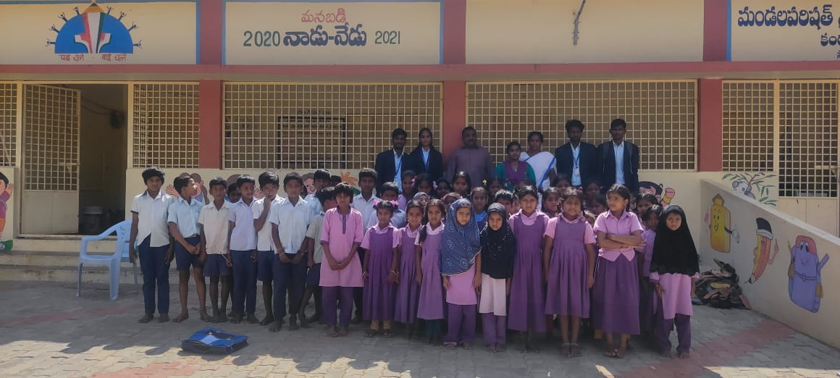

**ANGANWADI:**

* Anganwadi is a type of rural child care center in India started by the Indian government In 1998
* In this anganwadi school 2 members staff is their ( TEACHER,HELPER)
* Total 14 kids is there in this anganwadi school and due to fever less number of peoples are attended in last 20 days
* For the children food is balamrutam and milk is food for children
* Every month they provides the iron tablets for the children’s

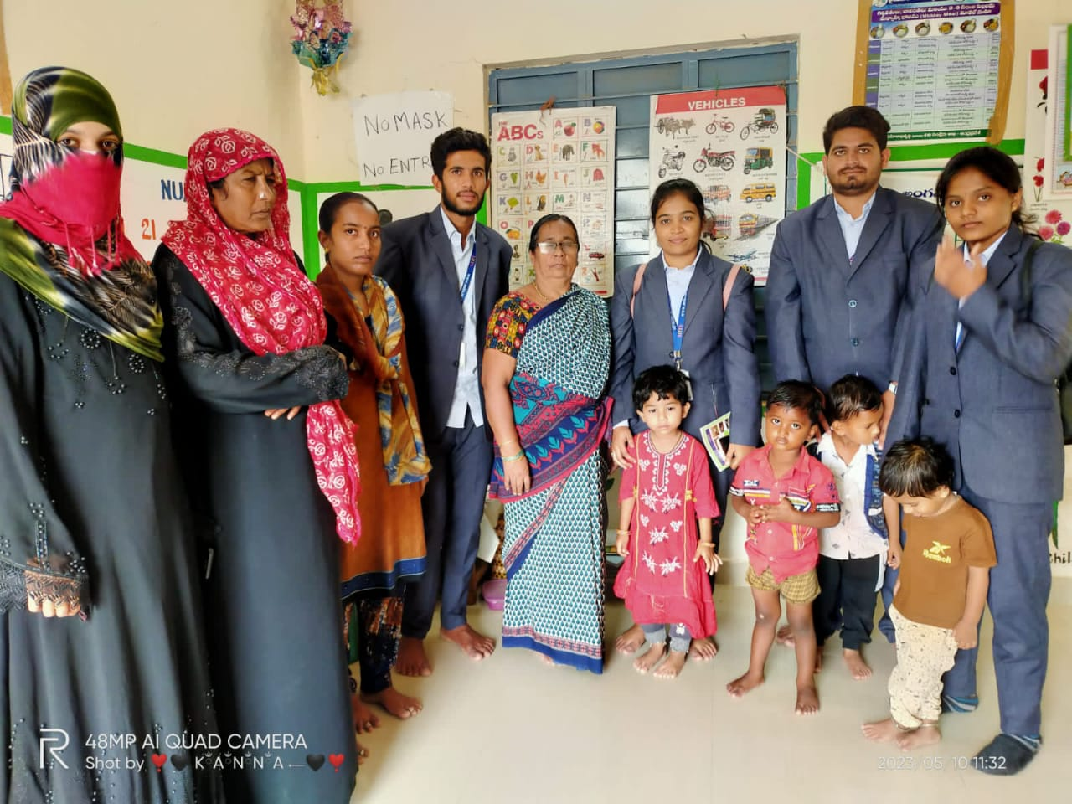

|  |  |
| --- | --- |
| C:\Users\admin\AppData\Local\Packages\5319275A.WhatsAppDesktop_cv1g1gvanyjgm\TempState\54229ABFCFA5649E7003B83DD4755294\WhatsApp Image 2023-01-18 at 21.48.33.jpg | C:\Users\admin\AppData\Local\Packages\5319275A.WhatsAppDesktop_cv1g1gvanyjgm\TempState\8613985EC49EB8F757AE6439E879BB2A\WhatsApp Image 2023-01-18 at 21.48.33.jpg |

7. **Nutrition, Health and Wellbeing**

* Hospital is established in the year of 2014
* In the hospital total 17 member staff are available including 2 members doctors
* Tablets and medicine facility are well in the hospital
* The medical equipment are deficiency is there in hospital
* Ambulance facility is not available in the hospital



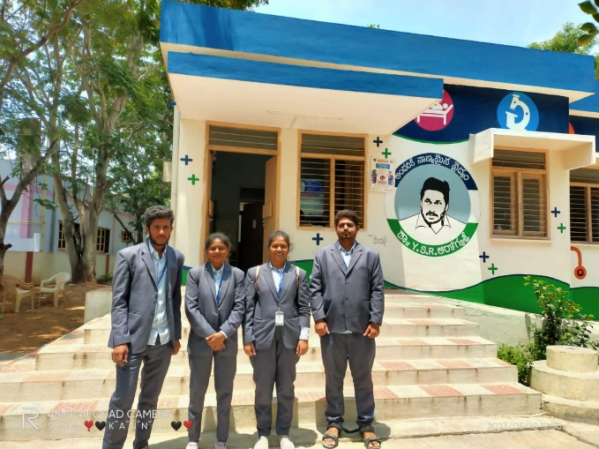

In the Village the Nutrition for the pregnant ladies and born child is maintained by Anganwadi School. There is a Clinic available for health issues. The Village will be having every month checkup camp to get treated

**8. Water Resources and Sanitation:**

Water resources are the back bone of the every village, and in the kandur water facilities are fully available. Due to heavy rain fall in the last year. Full of water is available for a griculrurelly. For agriculturally lot of water facilities are available in the kandur and nearby villages. For because of water facilities is only lot of peoples are depending the agriculture formers, and also agricultural agriculture labors

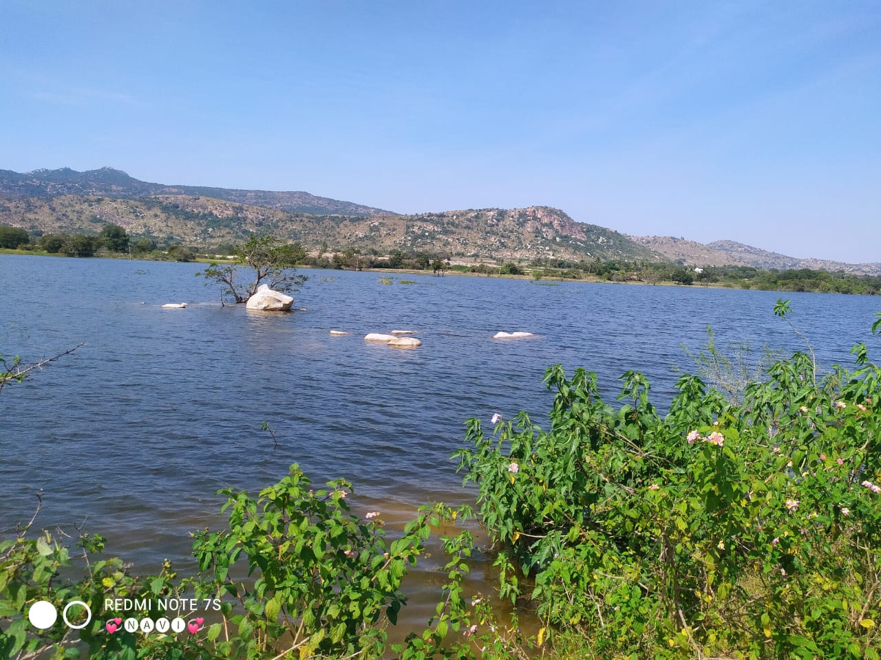

**9.Skill Development and Job Creation:**

In KANDUR, we haven’t found any skill development center at present in the village which creates jobs for the people of the village. Hear majorly jobs are based on the milk industry and agriculture industry in kandur village

**10. Sustainability and climate action:**

The climate of KANDUR is very lively. When we visited the village, we have observed that the lifespan of the people living there is around 65-70 climatically in the village seasons-based rain and and climatically cool area is these

**11. Electricity and Clean Energy**

* Electricity facility is more important for the village development any field.
* In the electrical substation 5 members staff is there including watchman
* There is no power cut for agriculturally, home purpose and industrially also (small scale industries )

|  |
| --- |
|  |

**12. Family Income:**

* Economically village peoples are better than near villages. Because of formers and small scale industries and small businesses
* Formers annual incomes are average per annum 1, 00, 000 .
* sometimes it is happens based on crop rates and quantity and environmental conditions either increase are decrease
* daily labor’s average annual income is 70,000 to 80,000
* some peoples can do the hand works and their annual incomes are up to 60,000
* these are major family income sources of the village

|  |  |
| --- | --- |
|  |  |

|  |
| --- |
|  |

**13. Infrastructure:**

**ROADS:**

In the kandur village road facilities are not well in the Entire village. Recently government of Andhra Pradesh and roads and buildings authority was giving the permissions for roads. New roads in kandur village .and it is damaged before 6 months due to heavy rain fall in village

|  |
| --- |
|  |

**B. WATER TANKS**: -

Water tank facility is well in the kandur village hear in different locations. near 5 to 6 water tanks age constructed for providing the drinking water to the hole kandur village .hear water tanks are maintained by the gram serpent.

**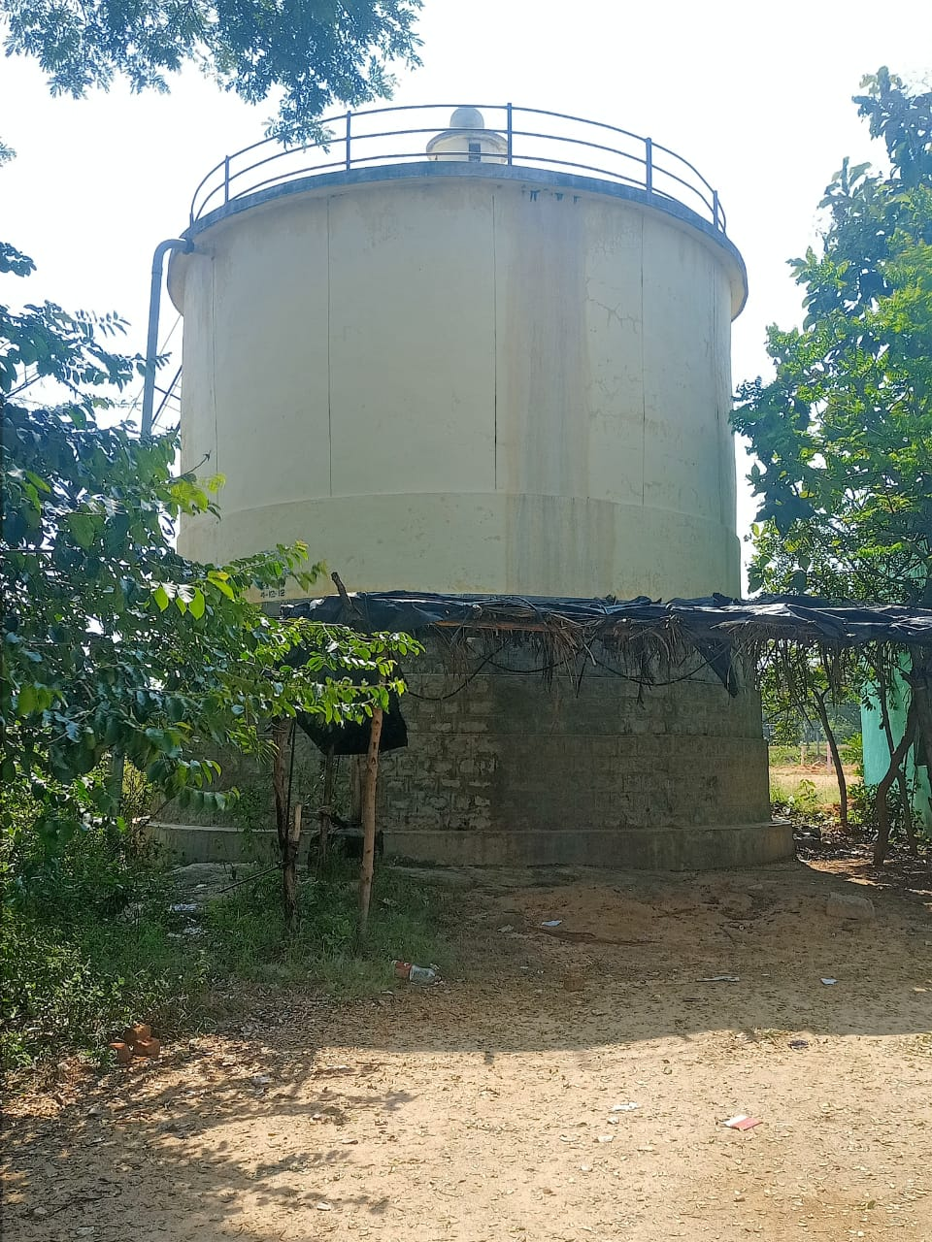**

* **COMMUNICATION FACILITY: -**
* **Hear locally channel facility is here to provide communication ( news , advertisement )**
* **Telephonic communication also well in the kandur village**
* **These are major communication facilities in the village e**

**Bridges:**

Kandur village bridge contractions are processing this government doing this village. During the last year heavy rain Fall Bridge is totally destroyed. And hear newly constructed bridge is there .due to bridge construction lot of problems like ….

* Transport
* School children’s facing to go to school to cross the bridge

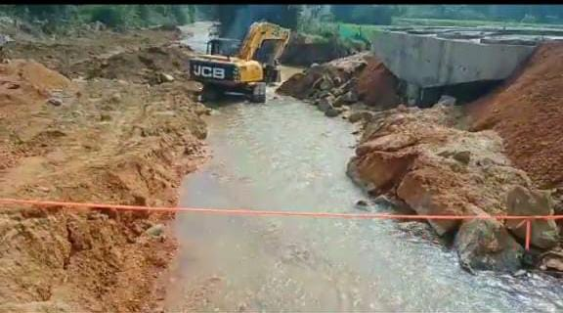

**STORAGE FACILITY;-**

Storage facility is the one of the biggest factor for the agriculture hear storage facility is not there in the kandur village the is the biggest drawback of the agriculture field in the village

**Irrigation Facilities:**

As per the villagers said, the village people has faced a water problem during the past few years which have lead them to depend on the labor work. After the rains, in the past few months has filled the pond of the village but they aren’t interested to take any risk and restart the agriculture.

**14. Implementation of Govt. Schemes:**

|  |
| --- |
| C:\Users\admin\AppData\Local\Packages\5319275A.WhatsAppDesktop_cv1g1gvanyjgm\TempState\F9B902FC3289AF4DD08DE5D1DE54F68F\WhatsApp Image 2023-01-15 at 20.40.43.jpg |

These are total eligibility families’ and for the government schemes and the total government spent

**Mid-day meal scheme are properly implemented**

Strongly agree – in KANDUR village school there is no proper maintenance of mid-day meals to the students they are cooking what they have at that time only. Even though they are not providing the eggs properly.

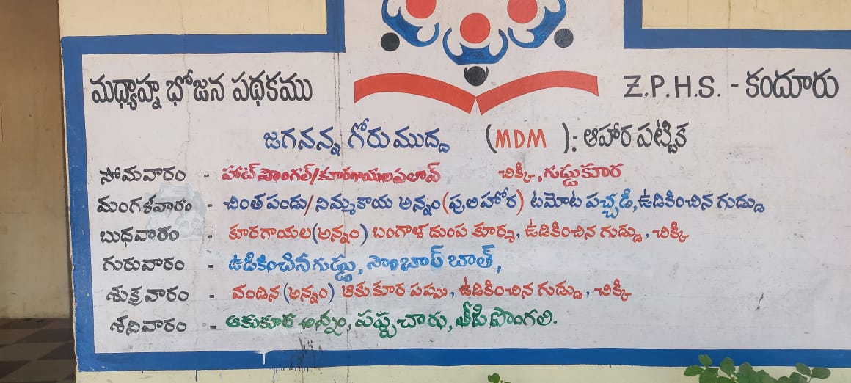

**Beneficiaries of Ammavadi scheme are receiving money in time**

Agree – in KANDUR village the students who are eligible to the Ammavadi scheme they are properly getting the returns from the govt. if there is any student is missed than he is getting in the second list.

**Any problem related to Reith Barossa is quickly addressed**

Agree village if any problem is arrived related to Raithu-bharosa scheme is quickly addressing.

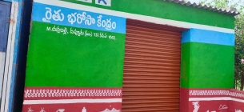

**All eligible workers are enrolled to MGNREP without discrimination**

Strongly Agree – in KANDUR village there is no discrimination among the people. All the eligible candidates are registered in MGNREP scheme.

|  |
| --- |
|  |

**Rate the Network connectivity in the village**

Average – in KANDUR village there is only 0 network providers are there they are Airtel and Jio. But there is no availability of high speed internet.

**Road connectivity to nearby town through public services is available for**

Agree -Daily 4 Times – in KANDUR village there is only 0 busses are available per day to go for the nearest town,

**Frequency of power cut problem in your area**

Agree-0-1 Times – in KANDUR village the power is cutting in a day.

**Rate the quality of water supply in your village**

Good – in KANDUR village there is good water supply but some florin is there in the water

When we visited the village, the village serpent was providing pension cards for the old age

people of the village.

**POST OFFICE:**

* Post office is available in the kandur village
* In the post office nearly 700 savings accounts are maintained for Savings purpose
* 3 Members of staff is available in the post office
* Average 10,00,000 turnover in a month
* Hear registered and speed posts are available in the postal services Due to postal department

**BANK:-**

Saptareri bank are available in the kandur village. Saptareri bank are established in the year of 1982. Hear in the bank total 6 members of staff are available (including temporary staff) Saptareri bank are providing different loans for formers and small scale industries also and personal loans. This bank is sponsored by Indian bank

* Savings account
* Current account

These are the major services inn the bank

* Fixed deposits
* Loans
* Total number of account holders -13000
* Number of loans -3500

**15. Any other relevant issue for discussion:**

In KANDUR there is main problems is roads. The roads not good there is got roads, peoples are facing

So many problems to travelling one place to another place.

Kandur village bridge contractions are processing this government doing this village. But bridge

is not complete means there is so many problems they spaces they are given bellow

* Transport
* School children’s facing to go to school to cross the bridge

**16.Suggestions Offered:**

**FOR AGRICULTURE: -**

* ➢ Formers most concentrate on cultivation of ground nuts and paddy to generate Income by using general water resources.
* ➢ Formers most educate about crop insurance to protect their crops from loss by any causes / reasons
* ➢ Government have control on digging of bore wells because useless bore wells create more problems to the environment.
* ➢ Implementation of land reforms.
* ➢ Plant protection and improved seeds.
* ➢ the government should take steps to aware the formers about the pesticides to protect their crops from insects.

**FOR SCHOOLS: -**

* to educate the children’s to take COVID-19 PRICAUSTIONS.
* They need to maintain proper building for primary school.
* to construct toilets for girls.
* The school building is very to solve the leakage problem and they need to one

**FOR VILLEGERS:**

* Improve the transport facilities.
* they have more water resources but all peoples cant consume that water facilities because pipe lines are damaged.
* Improve drainage system and use toilets.
* To keep clean their streets and surroundings and use dustbins.

**FOR PANCHAYATH: -**

* to improve construct roads.
* to improve school building.
* Establishment of medical clinic.
* Better drainage system.
* to educate the villagers about COVID-19 and make sure that vaccinated.
* Establishment of mineral water plant.

**17. Conclusion:**

The village which is located in Somala mandala with the 5376 population is there in this village. In this village most of the peoples is depending on agriculture. We are observing on that village they need to improve public health and sanitization measures, literacy, female empowerment, enforcement of law and order, land reforms, infrastructure like irrigation, electricity, transportation, and availability of credit and eradication of poverty. In conclusion, we can say that a villages are the back bone of the economy. Also, this village is a part of all the villages of the India where people still live in peace and harmony. Besides, the people of the village are friendly and lives a happy and prosperous life as compared to the people of urban areas

|  |
| --- |
|  |